CREATE OR REPLACE PROCEDURE process_employees

IS

CURSOR emp_cursor IS

SELECT empid

FROM employees;

BEGIN

FOR v_emp_rec IN emp_cursor

LOOP

raise_salary(v_emp_rec.empid, 10);

END LOOP;

END process_employees;

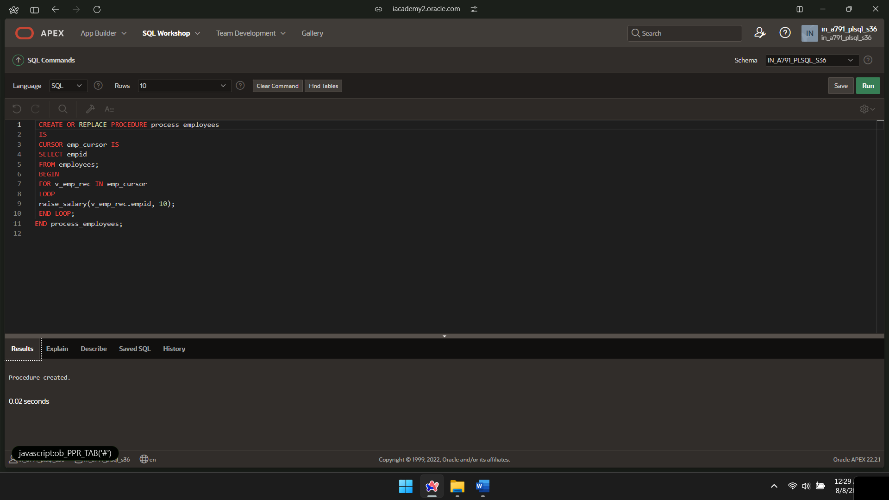

BEGIN PROCESS_EMPLOYEES;

END;

